“Київський фаховий коледж зв’язку”

Циклова комісія Комп’ютерної та програмної інженерії

**ЗВІТ ПО ВИКОНАННЮ**

# **WORK-CASE №6**

з дисципліни: «Операційні системи»

**Тема: «Робота з користувачами через термінал»**

Виконали студенти

групи КСМ-13а

Команда BBC:

Петрик С.С,

Панчук О.С.

Перевірив викладач

Сушанова В.С.

Київ 2023

**Завдання №1  
виконав Панчук О.С.**

Z Shell (zsh) is a command prompt and shell on UNIX and UNIX-like operating systems. It includes numerous advanced features such as auto-completion of commands, color-coded syntax highlighting, command history, and support for terminal themes. Zsh provides the user with more options and convenience when interacting with the command line compared to standard shells such as Bash. You can install it, for example, like this:

sudo apt-get install zsh

Features:

Improved auto-completion of commands and file paths.

Ability to manage command history.

Expanded support for themes and the ability to customize the appearance of the terminal.

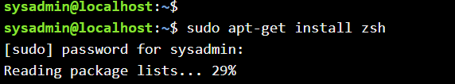

2)

Friendly Interactive Shell (Fish) is a command line interpreter and shell in UNIX-like operating systems. Fish is designed to improve the user's interactive interaction with the system. It features color-coded syntax highlighting, auto-completion of commands and parameters, and the ability to customize the terminal appearance. Fish simplifies the work with commands and provides a more user-friendly environment than some other command prompts. You can install it with the following command:

sudo apt-get install fish

Features:

Color highlighting of command syntax and output.

Built-in auto-completion of commands and parameters.

Easy customization through the graphical interface.

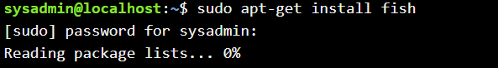

**Завдання №2**

**Виконав Петрик С.С**

**Завдання №3**

**Виконав Петрик С.С**

And the same way to setting up passwords for all other users

**Висновки:**

**Виконав: Панчук О.С**

As a result of the Work-case 6 task, several command prompts were installed in the operating system workspace, in addition to the standard bash. We created 10 new users and assigned them to five groups: Technical support, Developers, Financiers, Founders, and Guests. Each group was assigned a default command prompt according to the requirements of the task.

Technical support was assigned bash as the command prompt, Developers were assigned command prompt 1, Financiers were denied access to command prompts, Founders were assigned command prompt 2, and Guests were also denied access to command prompts.

Each group of users demonstrated their skills and capabilities in their command prompt by performing operations such as collecting information about the system, determining the basic configuration, system date, current directories, etc. This demonstrated the successful completion of Work-case 6 and compliance with the established requirements for command prompts and system users.